Research · Insights
AI Strategy · Pharmaceuticals

AI Initiatives in Pharma: 2025-2026
A landscape review of AI-driven drug discovery, R&D infrastructure, manufacturing, and diagnostics initiatives across leading pharmaceutical companies, drawn from public press releases and industry coverage.

Scope
Top global pharma companies; AI-driven discovery, R&D, manufacturing, and diagnostics
Report date
May 2026

Executive summary
Between 2025 and 2026, many leading pharmaceutical companies announced or deployed AI-driven initiatives across drug discovery, clinical development, manufacturing, and diagnostics. Key trends include drug discovery platforms (Novartis–Isomorphic[1], Takeda–Nabla/Iambic[2][3], AstraZeneca–Algen/CSPC[4][5]), AI-powered R&D collaborations (Merck–Mayo[6], Sanofi–QuantHealth[7], GSK–Helix[8], AstraZeneca–Immunai), and advanced computing infrastructure (Lilly’s NVIDIA “AI factory,”[9] Merck’s Google Cloud partnership[10], Roche’s NVIDIA-powered AI hub[11]). Companies also began applying generative AI and automation to back-office tasks (Merck’s LLM for report writing[12], J&J’s medical-robotic systems for trial planning[13]). Manufacturing and supply chain saw digital twin and robotics pilots (Lilly’s Omniverse digital twins for production[9], Teva’s AI-driven supply-chain innovation challenges[14]). Diagnostics partnerships emerged as well (Roche’s acquisition of PathAI for AI-pathology[15], AstraZeneca’s expanded Immunai deal for cancer biomarkers[16]).
Most announced initiatives are preliminary or R&D stage (pilot programs, partnerships, or collaborations) rather than fully commercial products. Few impact metrics were disclosed publicly; where available, companies cited time savings and accelerated timelines (Merck cut CSR writing from ~180h to 80h[12]; Takeda expects to cut discovery from ~6 to <2 years[2]). Ethical/regulatory notes are sparse, though AI safety is implied (Roche mentions NVIDIA NeMo guardrails[11], and Teva[14] and Bayer[17] emphasize compliance in use-case statements).

Table 1. Pharmaceutical AI Implementations (2025–2026)
Company (HQ) | Date | Use Case | Tech Type | Partners/  Vendors | Deployment Status | Impact/Scale | Reg./Ethical Notes | Sources
Novartis (Switzerland) | Feb 18, 2025 | Drug discovery (novel targets) | AlphaFold-based AI | Isomorphic Labs (UK) | Announced (expansion) | Added 3 new discovery programs[1] | Unspecified | Novartis press[1]
Pfizer (USA) | Jun 29, 2025 | Drug discovery (small molecules) | ML/physics-AI hybrid | XtalPi (US/China) | Ongoing collaboration | Demonstrated improved binding prediction (metrics N/R) | Unspecified | XtalPi press[18]
Roche (Switzerland) | Mar 16, 2026 | R&D infrastructure (compute) | GPU/AI hardware & software (NVIDIA BioNeMo, Omniverse) | NVIDIA (US) | Deployed (production) | ~3,500+ NVIDIA GPUs (largest pharma AI factory)[11] | NeMo Guardrails (safety) | Roche press[11]
Roche (Switzerland) | May 7, 2026 | Diagnostics (digital pathology) | AI pathology software | PathAI (US, acquired) | Announced acquisition | $750M upfront + $300M milestones; integrate AI IMS globally[15] | Regulatory approval pending | Roche press[15]
AstraZeneca (UK) | Jun 13, 2025 | Drug discovery (oral candidates) | AI-driven binding models | CSPC Pharma (China) | Announced | Potential deal value $1.62B (dev) + $3.6B (sales) | Unspecified | AZ press[5]
AstraZeneca (UK) | May 7, 2026 | Oncology R&D (biomarkers, MoA) | AI immunology platform (foundation models) | Immunai (US) | Expanded collaboration | Up to $37.5M payments; multi-year support through 2027[16] | Unspecified | Calcalistech[16]
AstraZeneca (UK) | Oct 6, 2025 | Drug discovery (CRISPR/AI genomics) | AI-driven functional genomics (AlgenBrain) | Algen Biotechnologies (US) | Announced | Up to $555M deal value[4] | Unspecified | Algen press[4]
AstraZeneca (UK) | Aug 5, 2025 | Clinical outcomes (oncology) | Federated analytics (AI Factories) | SOPHiA Genetics (US/CH) | Announced | Focus: breast cancer; federated ML on real-world data | Data privacy (federated, compliant) | SOPHiA Gen. press[19]
Merck (MSD) (USA) | Feb 18, 2026 | Drug discovery (target ID) | AI/ML platform (virtual cell models) | Mayo Clinic Platform (US) | Announced | Integrating multimodal patient data (no metric) | Data de-identification implied | Merck press[6]
Merck (MSD) (USA) | Jun 25, 2025 | Regulatory writing (CSRs) | LLMs (genAI) | McKinsey co-dev. | Deployed (pilot) | CSR writing time cut ~55% (180h→80h); 50% fewer errors | Achieved regulator-quality standards | Merck press[12]
Merck (MSD) (USA) | Apr 22, 2026 | Enterprise AI (R&D/commercial) | Cloud AI/agents (Gemini Enterprise) | Google Cloud (US) | Announced (multi-year $1B) | Covers 75,000+ employees, labs to help predict outcomes | Unspecified | Merck press[10]
Johnson & Johnson (USA) | Apr 27, 2026 | Discovery (screening, design) & clinical and manufacturing | AI/ML (unspecified; also robotics) | Internal (no vendor) | Production (CIO interview) | Lead discovery time halved; CSR docs cut 700h→15min; 2 compounds accelerated | Unspecified | Reuters[13]
GSK (UK) | Nov 18, 2025 | AMR drug discovery & surveillance | AI/ML models (surveillance) | Fleming Initiative/ Imperial College (UK) | Planned programs (2026) | £45M funding for 6 projects; using AI for antibiotic/fungal discovery[20] | Targets global AMR threat | GSK press[20]
GSK (UK) | Jan 7, 2026 | Precision R&D (genetics) | Genomics platform | Helix (USA) | Announced | Access to large exome/genome cohorts; support precision medicine decisions[8] | Unspecified | Helix press[8]
Sanofi (France) | Nov 3, 2025 | Clinical trial design (simulations) | Digital twin simulations | QuantHealth (USA) | Announced partnership | Will pilot virtual trial simulations (no metric); using real patient data | Uses de-identified health data | HealthcareITToday[7]
Bayer (Germany/USA) | Jan 7, 2026 | Biologics discovery (antibodies) | Generative AI for protein engineering | Cradle (NL/CH) | Announced (3-yr collab) | Integration in antibody R&D; platform can speed up bio design by ~12×[17] | Unspecified | Bayer press[17]
Lilly (USA) | Oct 28, 2025 | Drug discovery & R&D infrastructure | NVIDIA DGX SuperPOD (1,016 GPUs, BioNeMo) | NVIDIA (US) | Deployed (production) | “Largest AI factory” in pharma; trains foundation models; federated TuneLab platform[9] | Data privacy via federated learning | NVIDIA blog[9]
Lilly (USA) | Jan 12, 2026 | R&D (continuous learning, robotics) | Hybrid AI lab (BioNeMo, Omniverse, robotics) | NVIDIA (US) | Announced (co-innovation lab) | $1B investment over 5 years; “AI agents” for drug design; digital twins for manufacturing[21] | Unspecified | Lilly press[21]
Takeda (Japan) | Oct 14, 2025 | Biologics discovery (antibodies) | AI protein design (JAM) | Nabla Bio (USA) | Expanded research deal | Potential >$1B milestones; 3–4 week design-to-test loop[3] | Unspecified | Reuters[3]
Takeda (Japan) | Feb 9, 2026 | Drug discovery (small molecules) | AI-driven molecular modeling | Iambic (USA) | Announced (multi-year) | Upfront + $1.7B milestones; aims <2-year discovery timelines[2] | Unspecified | Reuters[2]
Teva (Israel) | Nov 19, 2025 | Open innovation (R&D/manufacturing) | AI/Industry 4.0 platform | Global startups, tech players | Launched (pilot challenges) | First cohort: 7 challenges (e.g. predictive maintenance, AI trial design)[14] | Unspecified | Teva press[14]

Figure 1. Timeline of AI deployments in pharma
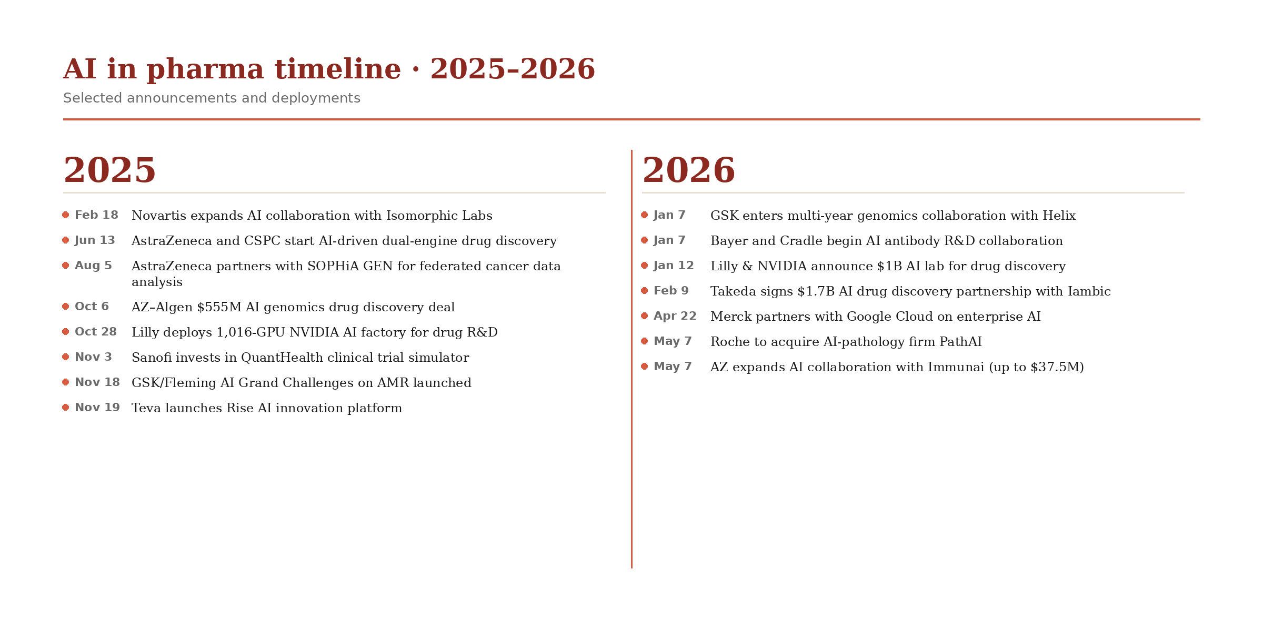

Findings
- Trends: The table and timeline show that AI initiatives are concentrated in R&D/translation, especially drug discovery (target identification, molecule design) and precision/virtual development (biomarkers, trial simulation). Many deals involve AI startups or big tech partners (XtalPi[18], Isomorphic[1], Immunai[16], Algen[4], Cradle[17], Google[10], NVIDIA[9]). Infrastructure plays a growing role: companies are building “AI factories” (Lilly, Roche[11]) and digital platforms (GSK–Helix[8], Teva Rise[14]) to harness data and compute. Notably, generative AI and automation have started entering regulated processes (Merck’s CSR writing by LLM[12], J&J’s robotics in trial planning[13]). Imaging and diagnostics AI is on the rise (Roche/PathAI[15], J&J’s AI biomarker lab[13]), reflecting AI’s promise in personalized medicine.
- Gaps: Despite the volume of announcements, public impact metrics remain sparse. Most reported metrics are projections (e.g. “up to $555M” deals[4] or time reductions). We see few completed product launches; most projects are still in pilot or early implementation. Regulatory and ethical discussion is limited; only Roche explicitly mentions AI guardrails[11], and Teva[14]/Bayer[17] frame AI use in R&D without detail on compliance. Applications in commercial/marketing domains are largely absent from 2025–2026 disclosures. In short, pharma’s 2025–2026 AI focus is on bolstering R&D efficiency via partnerships and tech buildouts, with regulatory/ethical oversight only implicitly addressed.

References
- https://www.isomorphiclabs.com/articles/isomorphic-labs-announces-novartis-collaboration-expansion
- https://www.reuters.com/business/healthcare-pharmaceuticals/takeda-deepens-ai-drug-discovery-push-with-17-billion-iambic-deal-2026-02-09/
- https://www.reuters.com/business/healthcare-pharmaceuticals/us-biotech-nabla-bio-japans-takeda-expand-ai-drug-design-partnership-2025-10-14/
- https://www.businesswire.com/news/home/20251006056468/en/Algen-Biotechnologies-Announces-Multi-Target-Partnership-to-Advance-AI-Powered-Drug-Discovery-in-Immunology-with-AstraZeneca
- https://www.astrazeneca.com/media-centre/press-releases/2025/astrazeneca-enters-into-collaboration-with-cspc.html
- https://www.merck.com/news/merck-and-mayo-clinic-announce-new-research-and-development-collaboration-to-support-ai-enabled-drug-discovery-and-precision-medicine/
- https://www.healthcareittoday.com/2025/11/03/sanofi-and-quanthealth-team-up-to-advance-ai-powered-digital-twins-and-clinical-trial-simulation/
- https://www.helix.com/press-releases/helix-announces-multi-year-strategic-collaboration-with-gsk-to-drive-precision-medicine-development
- https://blogs.nvidia.com/blog/lilly-ai-factory-nvidia-blackwell-dgx-superpod/
- https://www.merck.com/news/merck-and-google-cloud-partner-to-accelerate-agentic-ai-enterprise-transformation/
- https://www.roche.com/media/releases/med-cor-2026-03-16
- https://www.merck.com/news/merck-expands-innovative-internal-generative-ai-solutions-helping-to-deliver-medicines-to-patients-faster/
- https://money.usnews.com/investing/news/articles/2026-04-27/j-j-sees-ai-halving-the-time-to-generate-drug-development-leads
- https://ir.tevapharm.com/news-and-events/press-releases/press-release-details/2025/Teva-Launches-Rise-A-Global-Open-Innovation-Platform-to-Accelerate-AI-Industry-4-0-Smart-Manufacturing-Digital-Health-and-Biotech-Breakthroughs-for-Pharmas-Biggest-Challenges/default.aspx
- https://www.roche.com/media/releases/med-cor-2026-05-07
- https://www.calcalistech.com/ctechnews/article/bkhaclqcwe
- https://www.bayer.com/en/us/news-stories/ai-enabled-antibody-discovery-and-optimization
- https://en.xtalpi.com/xtalpi-and-pfizer-expand-strategic-collaboration-to-advance-ai-driven-drug-discovery-and-materials-science-simulations/
- https://www.sophiagenetics.com/news/sophia-genetics-expands-collaboration-with-astrazeneca/
- https://www.gsk.com/en-gb/media/press-releases/gsk-and-fleming-initiative-scientists-unite-to-target-amr-with-advanced-ai/
- https://investor.lilly.com/news-releases/news-release-details/nvidia-and-lilly-announce-co-innovation-ai-lab-reinvent-drug

